Assignment 3:

Docker is a self-contained unit of software thatcan be delivered on any server having its own isolated process and has its own file system. We would want to further explore Docker before we choose it for the deployment of our microservices. Basically,we would like to check the feasibility of the deployment and ease of use to make an informed decision. So perform the below-mentioned tasks and share your findings.

1. **Install Docker on a linux based machine (preferable Ubuntu-20).**

Installed Ubuntu 20 LTS version inside virtualbox and installed docker followed by <https://docs.docker.com/engine/install/ubuntu/> link.

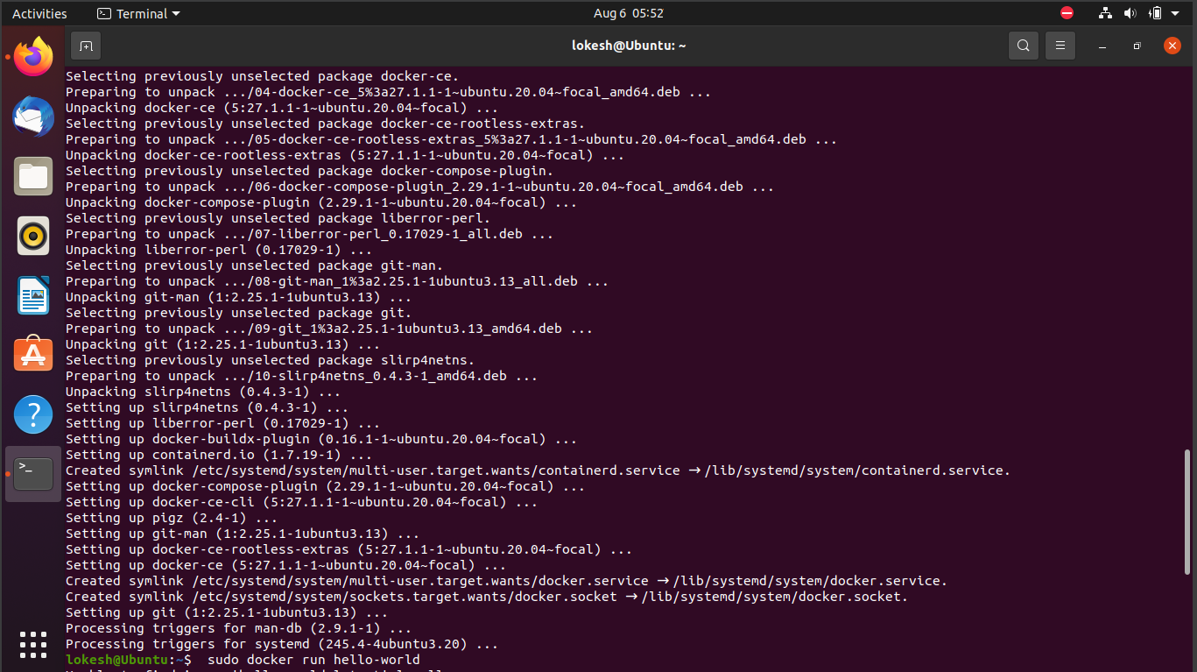

1. **Check Docker version**

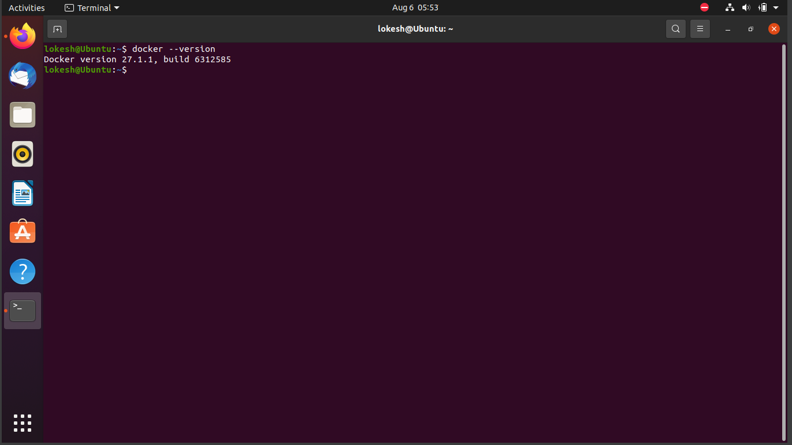

1. Launch Docker Hello World example

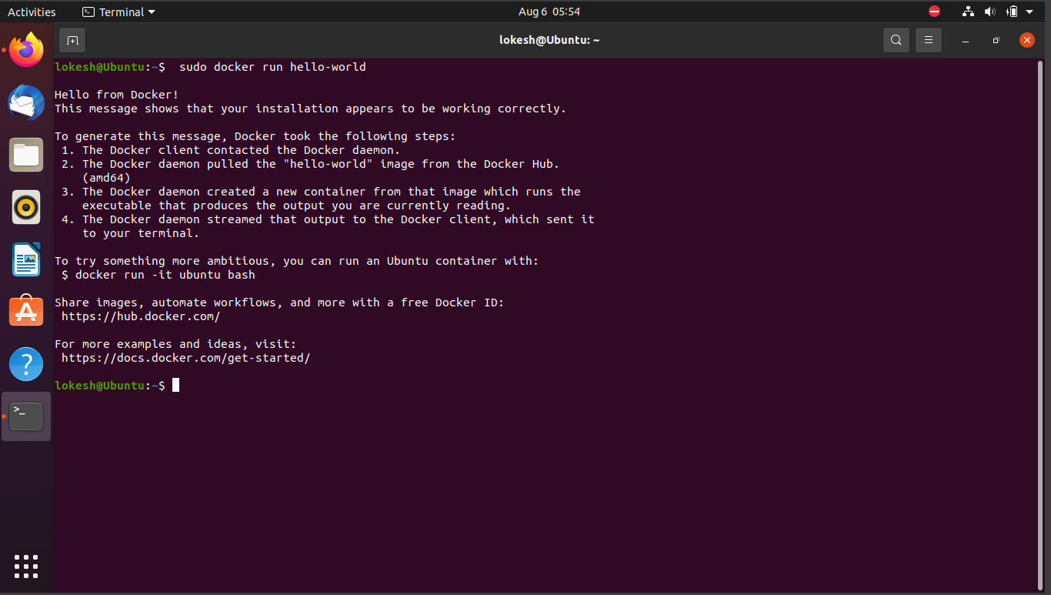

1. **List docker images**

